Bank lovker system using Enbbdedd

Abstract

The bank locker system using embedded technology is a secure and efficient solution for managing customer valuables. This system employs advanced embedded systems to automate and enhance the security of traditional bank lockers. It integrates biometric authentication, such as fingerprint scanning or facial recognition, to ensure only authorized individuals can access the lockers.

The system also includeincludees a user-friendly interface for customers to manage their locker access and contents. Through this interface, customers can schedule locker access times, view transaction logs, and receive notifications for any activity related to their locker.

Additionally, the embedded system incorporates real-time monitoring and alerts for bank staff, ensuring prompt response to any suspicious activities or security breaches. This enhances overall security and reduces the risk of unauthorized access or theft.

Moreover, the system facilitates seamless integration with the bank’s existing infrastructure, allowing for easy management and scalability. It provides a reliable and efficient solution for banks to offer secure locker services to their customers while maintaining a high level of security and convenience.

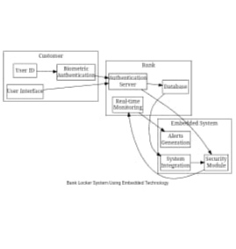Block diagram